The internet
Y12 - Cambridge International 9618 | Bit streaming and 2.2 | Student booklet
Name: _______________________________ | Date: _____________

This booklet has everything you need for the lesson in one place. Work through it in order:
- Learn sections show the key slides. Read them carefully - they explain the ideas and show worked examples.
- Task sections are where you practise. Each task uses what the slides just before it taught you.
- Tasks use real Cambridge 9618 Paper 1 questions where they exist. Task 6 is extension or homework.
Do Task 1 from memory before you turn the page.
Task 1 Recall test - network hardware [12 marks]
Closed book. 8 minutes.
1 Write the name of the device that matches each purpose. [6]
Purpose | Device
Forwards data only to the intended device on a LAN, using MAC addresses
Forwards packets between networks using IP addresses and a routing table
Connects wireless devices to a wired network using radio waves
Restores a weakened signal so it can travel further
Connects two LAN segments that use the same protocol
Converts digital data to analogue for a telephone line, and back again

2 Tick one box in each row to show whether the statement describes a MAC address or an IP address. [3]
Statement | MAC address | IP address
Set by the manufacturer and does not change
Read by a router to send a packet to another network
Held by the NIC or WNIC to identify the device on the LAN

3 Describe the role of a switch in a network. [3]
9618/12 May/June 2025 Q6(e).

Learn Check Task 1 and recap network hardware
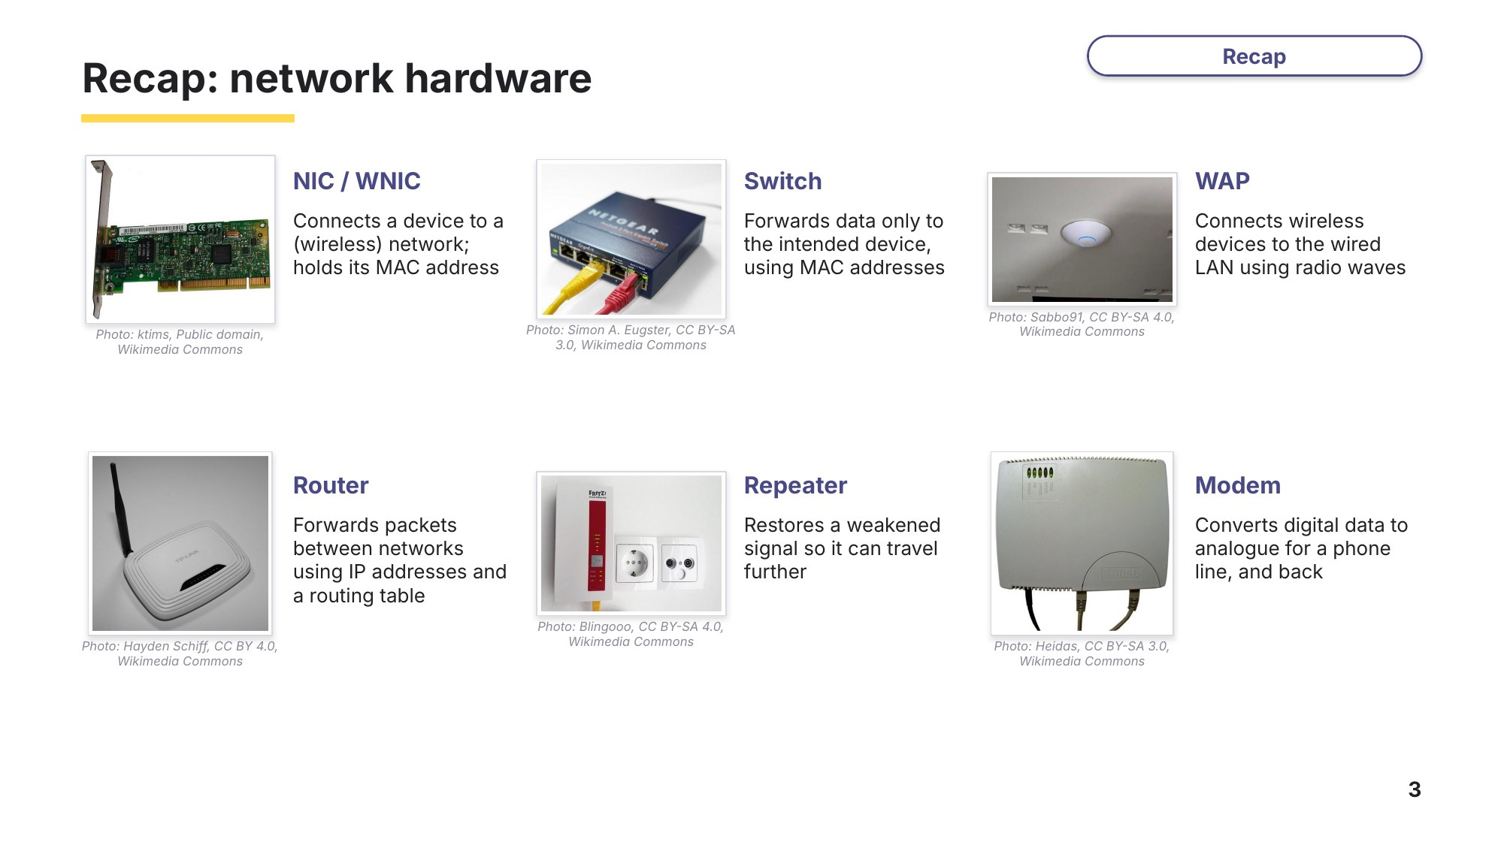
Slide 3 - Recap: network hardware
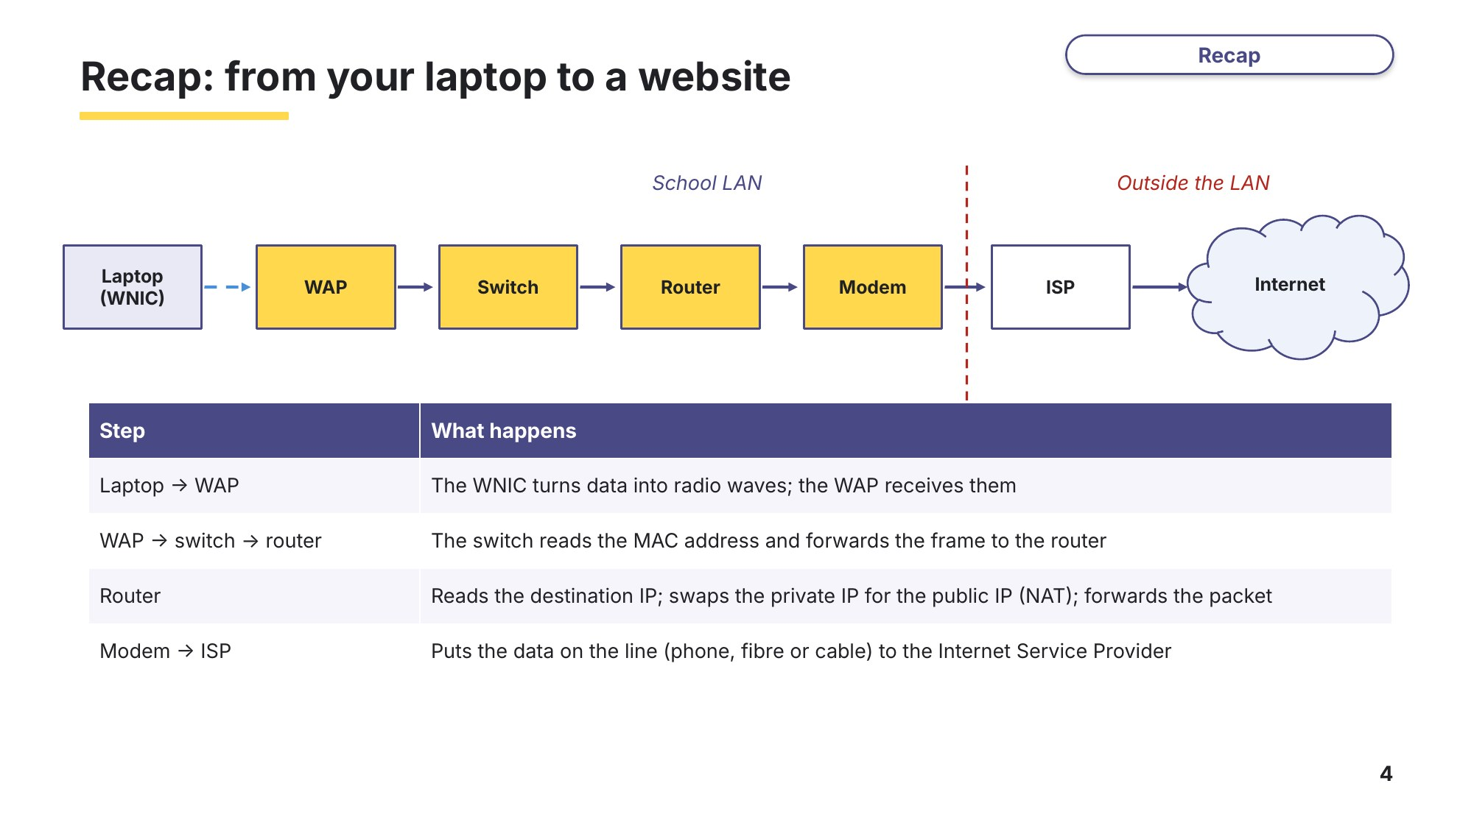
Slide 4 - Recap: from your laptop to a website

Learn Bit streaming
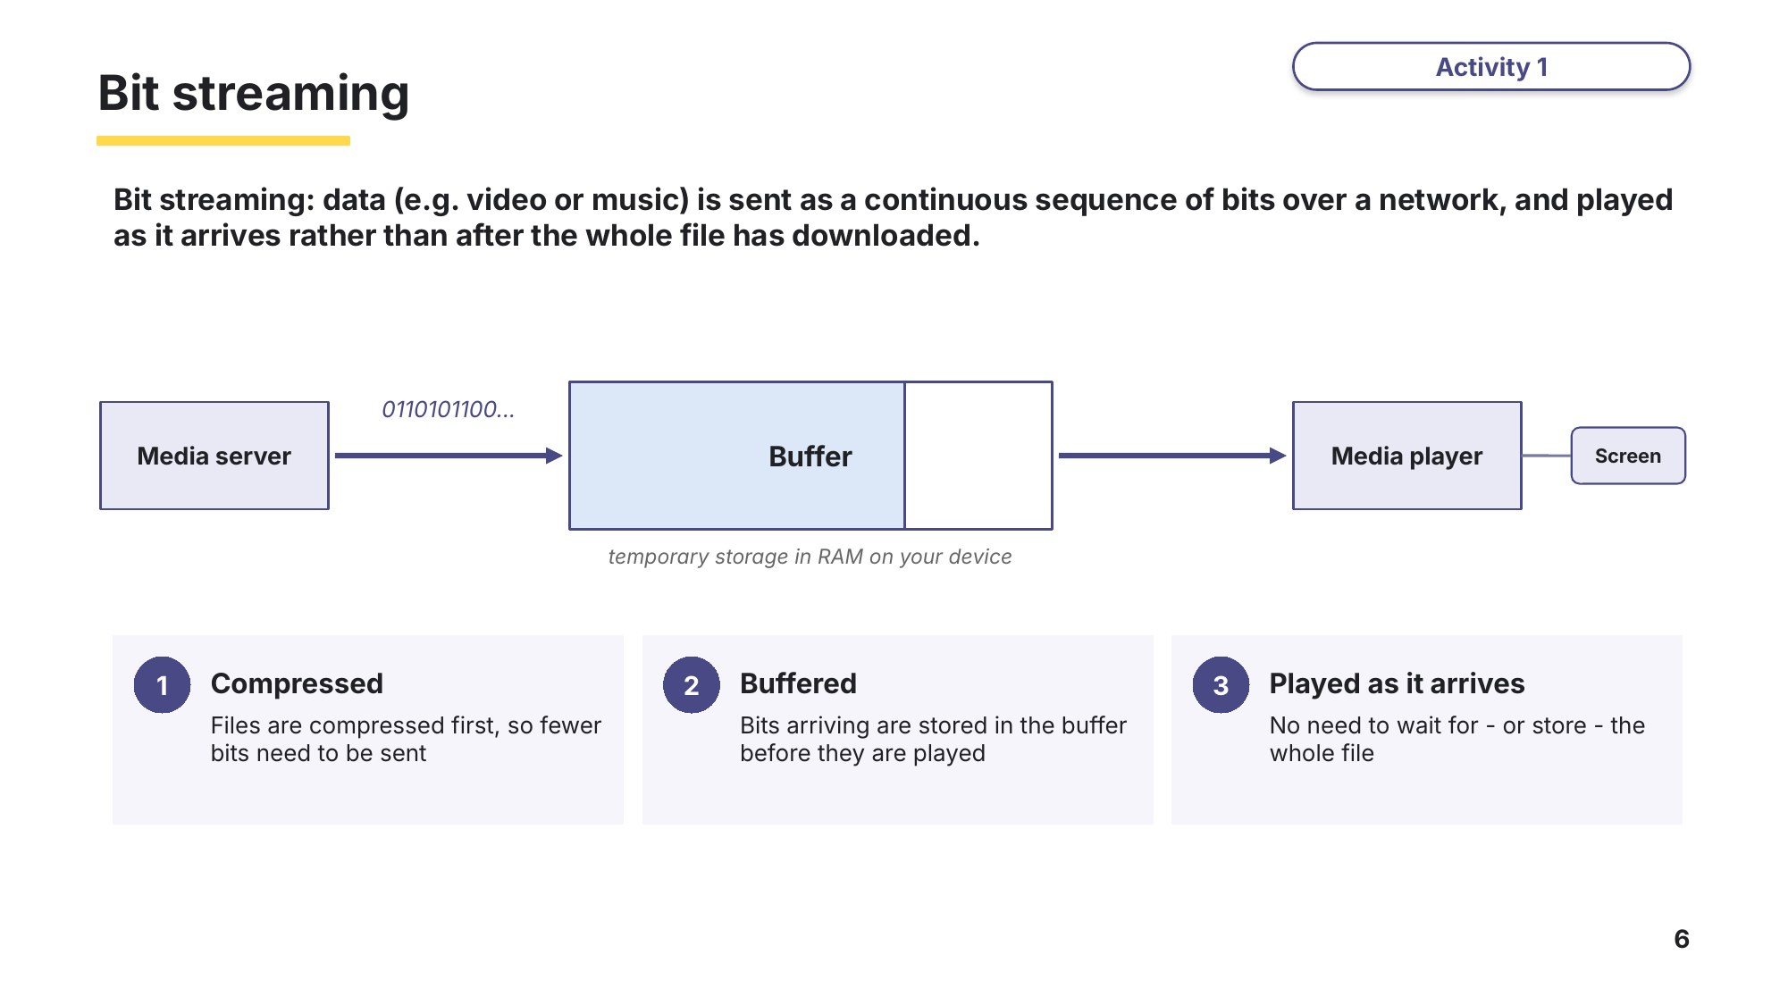
Slide 6 - Bit streaming
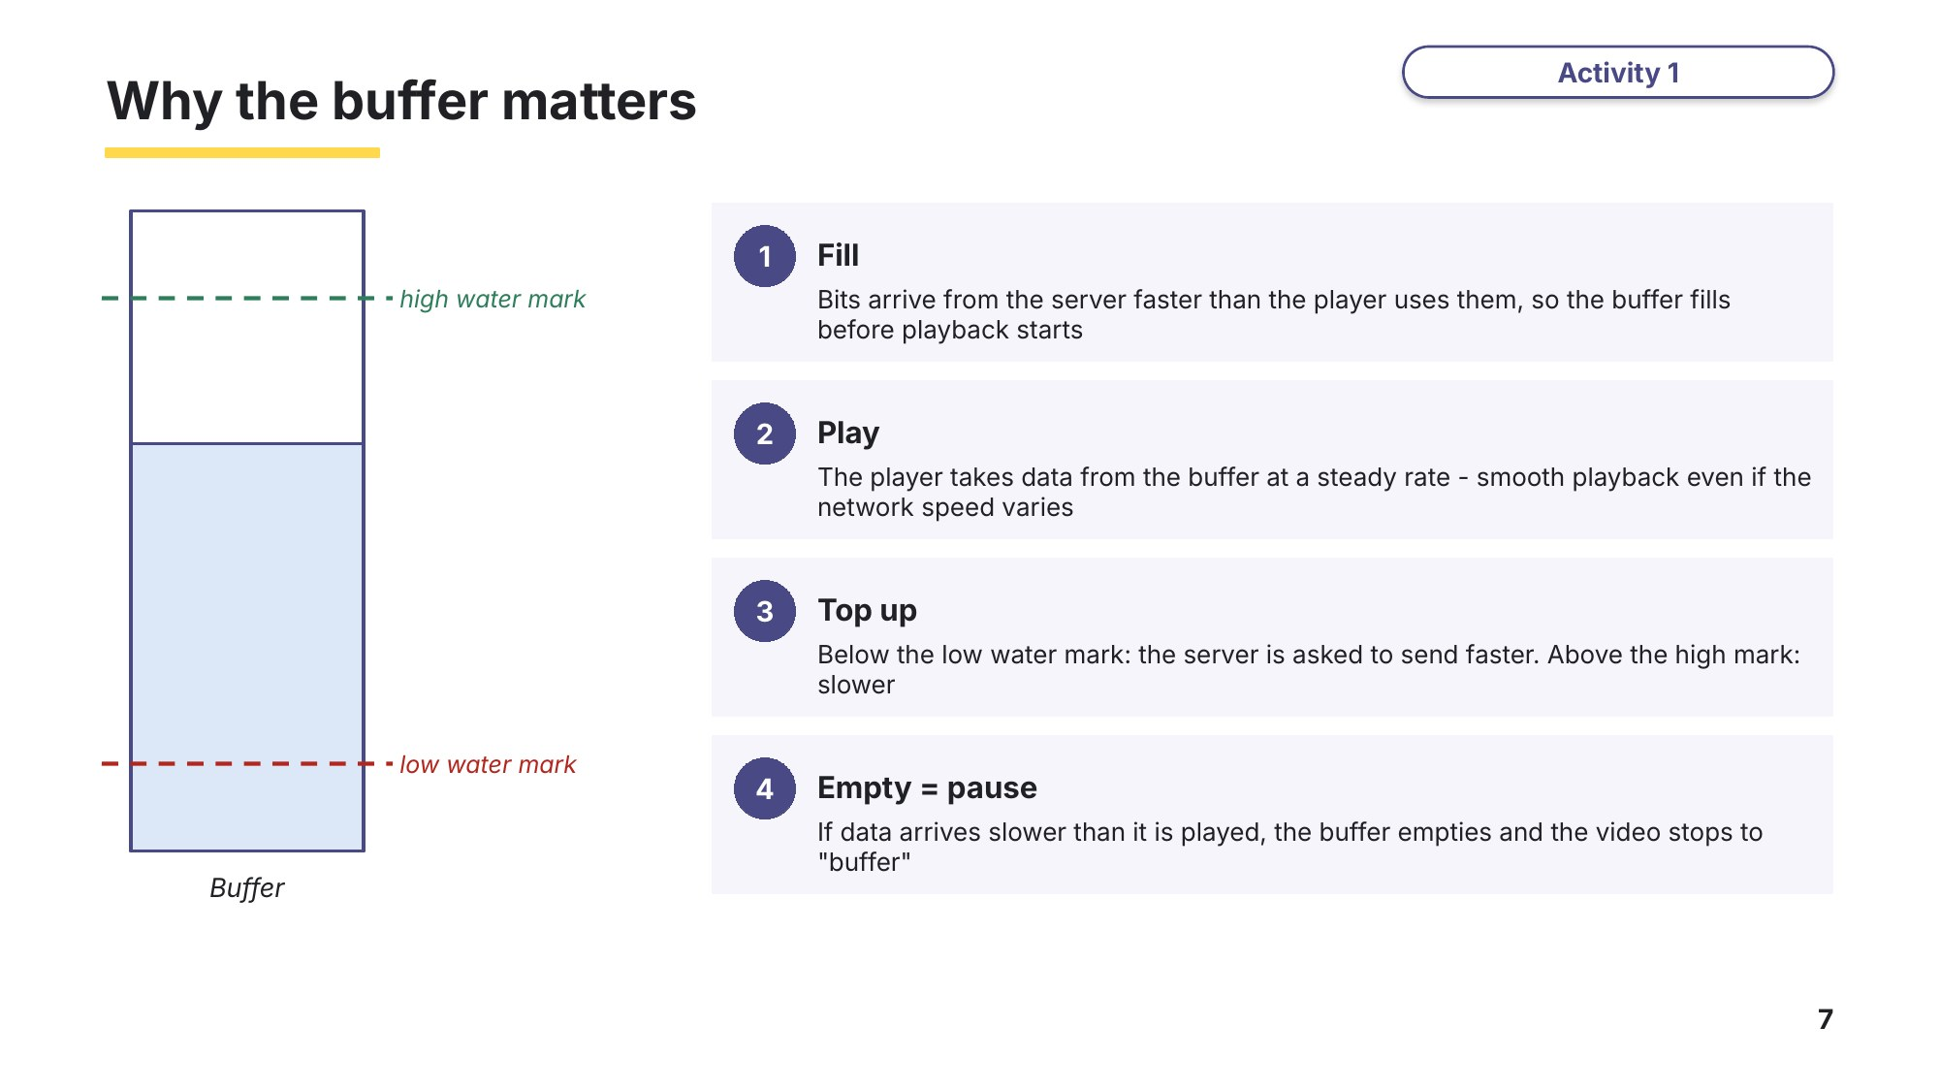
Slide 7 - Why the buffer matters
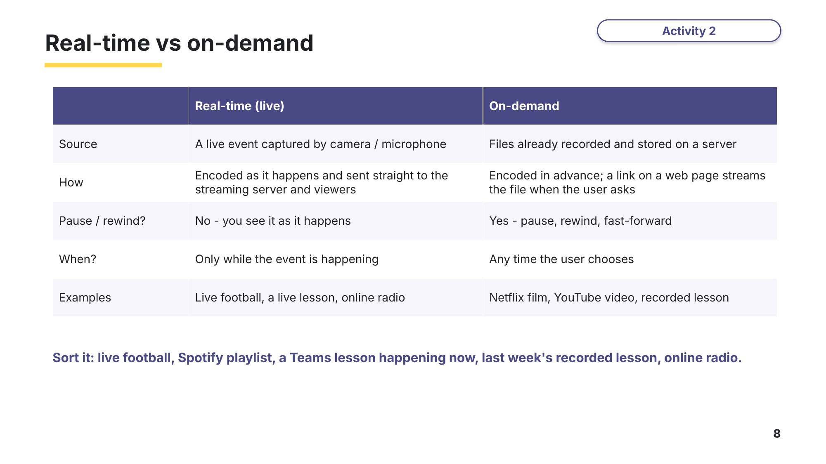
Slide 8 - Real-time vs on-demand
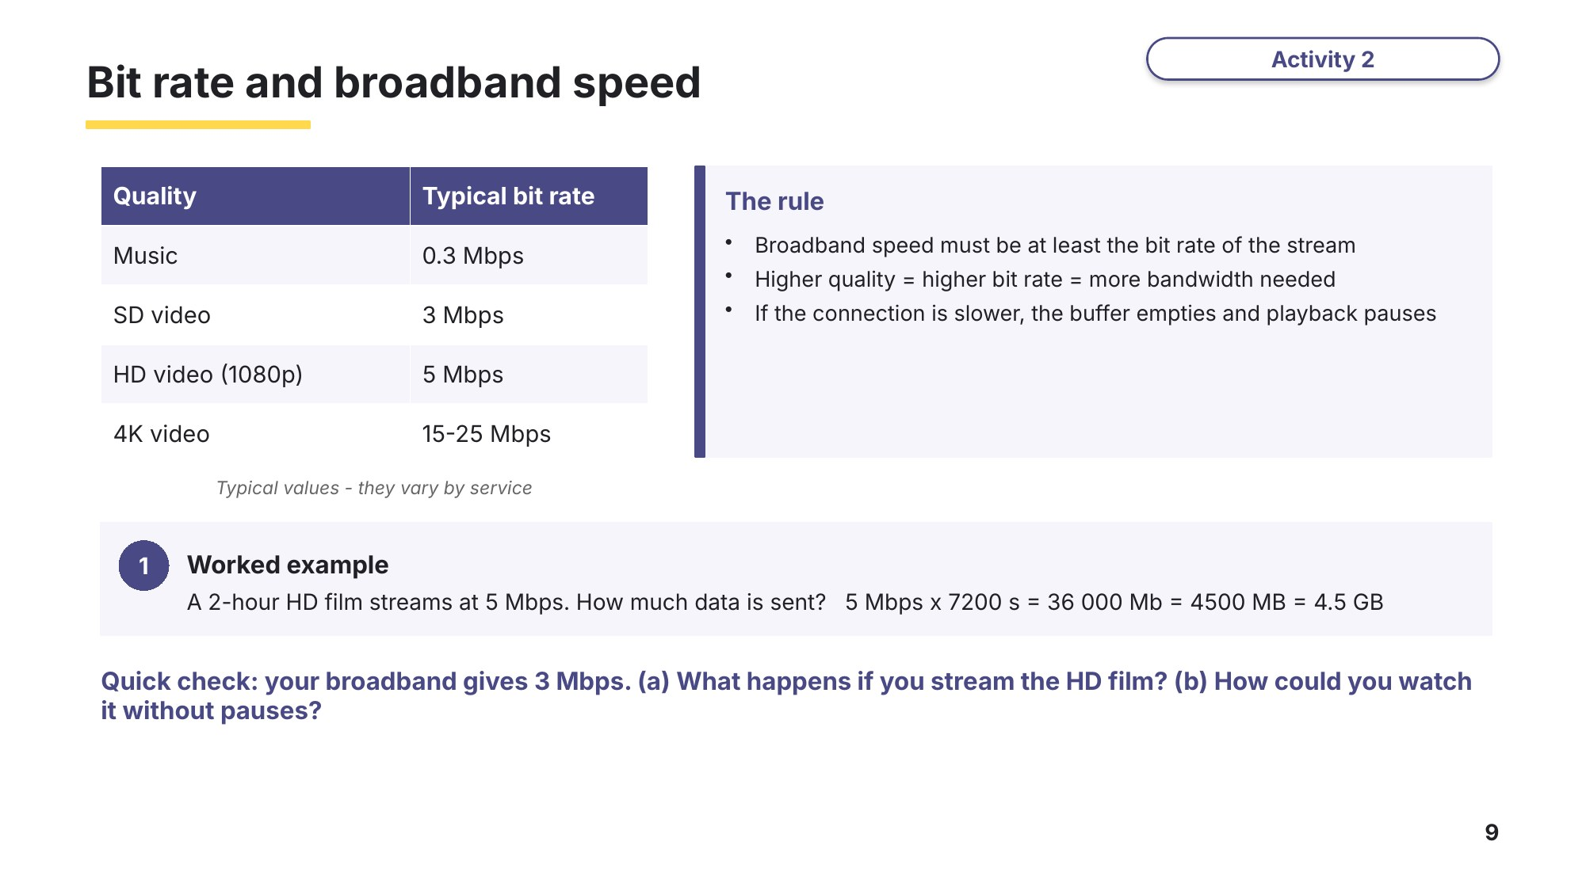
Slide 9 - Bit rate and broadband speed
Task 2 Bit streaming [12 marks]
(a) State what is meant by bit streaming. [1]
9618/11 May/June 2024 Q2(e)(i).

(b) Give two differences between real-time and on-demand bit streaming. [2]
9618/11 May/June 2024 Q2(e)(ii).
1

2

(c) Explain how bit streaming is used in a real-time video conference. [4]
9618/13 October/November 2024 Q9(c).

(d) A school puts a recorded 45-minute lesson online. The video streams at 4 Mbps (megabits per second).
(i) Calculate how much data, in megabytes (MB), is streamed for the whole video. Show your working. [2]

(ii) A student's broadband connection gives 2.5 Mbps. Explain what will happen when the student watches the video, and suggest one way to watch it without pauses. [3]
Exam-style question (bit rates / broadband speed).

Learn Exam technique - check your Task 2 answers
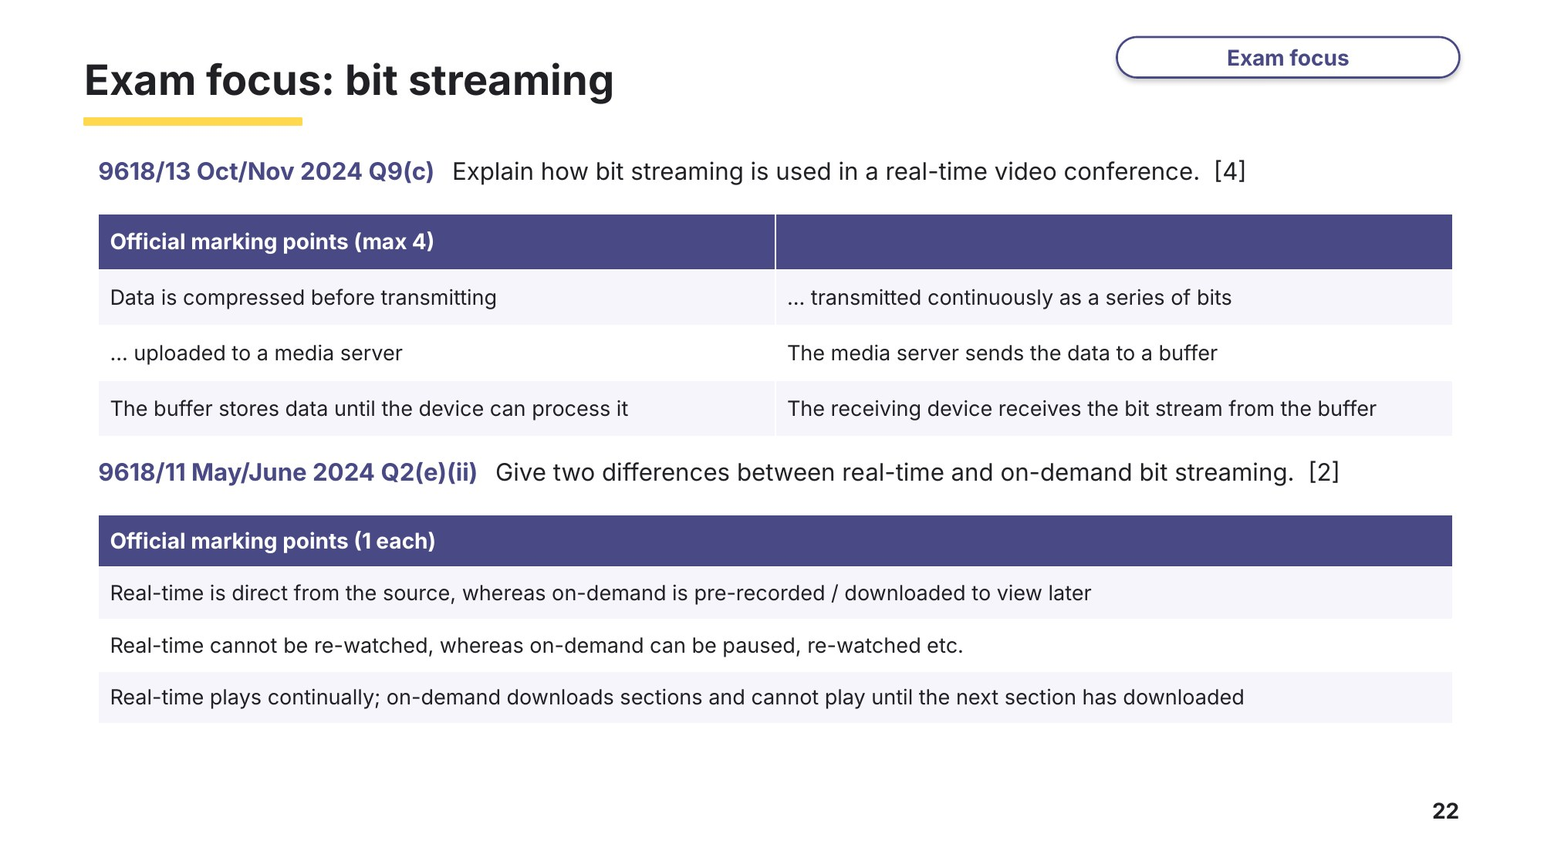
Slide 22 - Exam focus: bit streaming

Learn The internet and the hardware that supports it
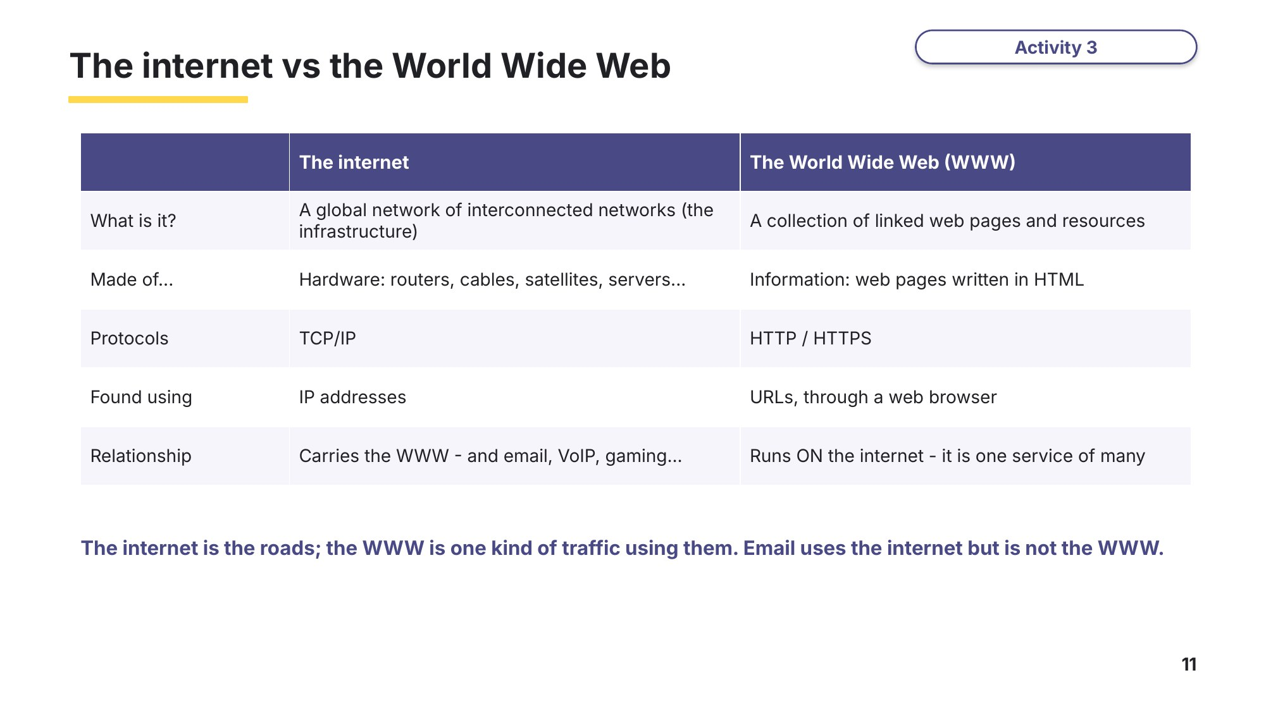
Slide 11 - The internet vs the World Wide Web
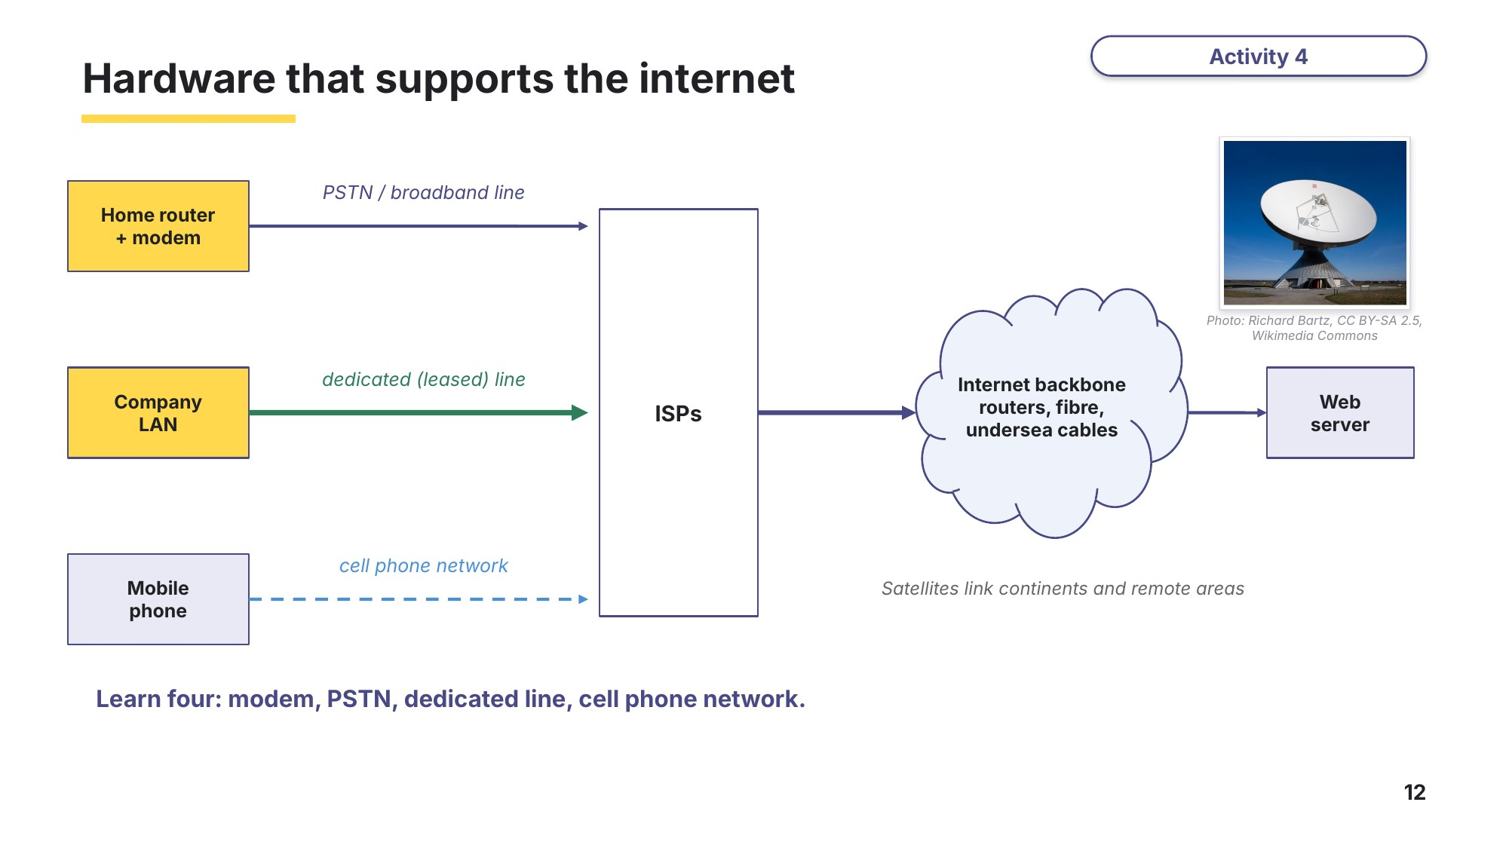
Slide 12 - Hardware that supports the internet
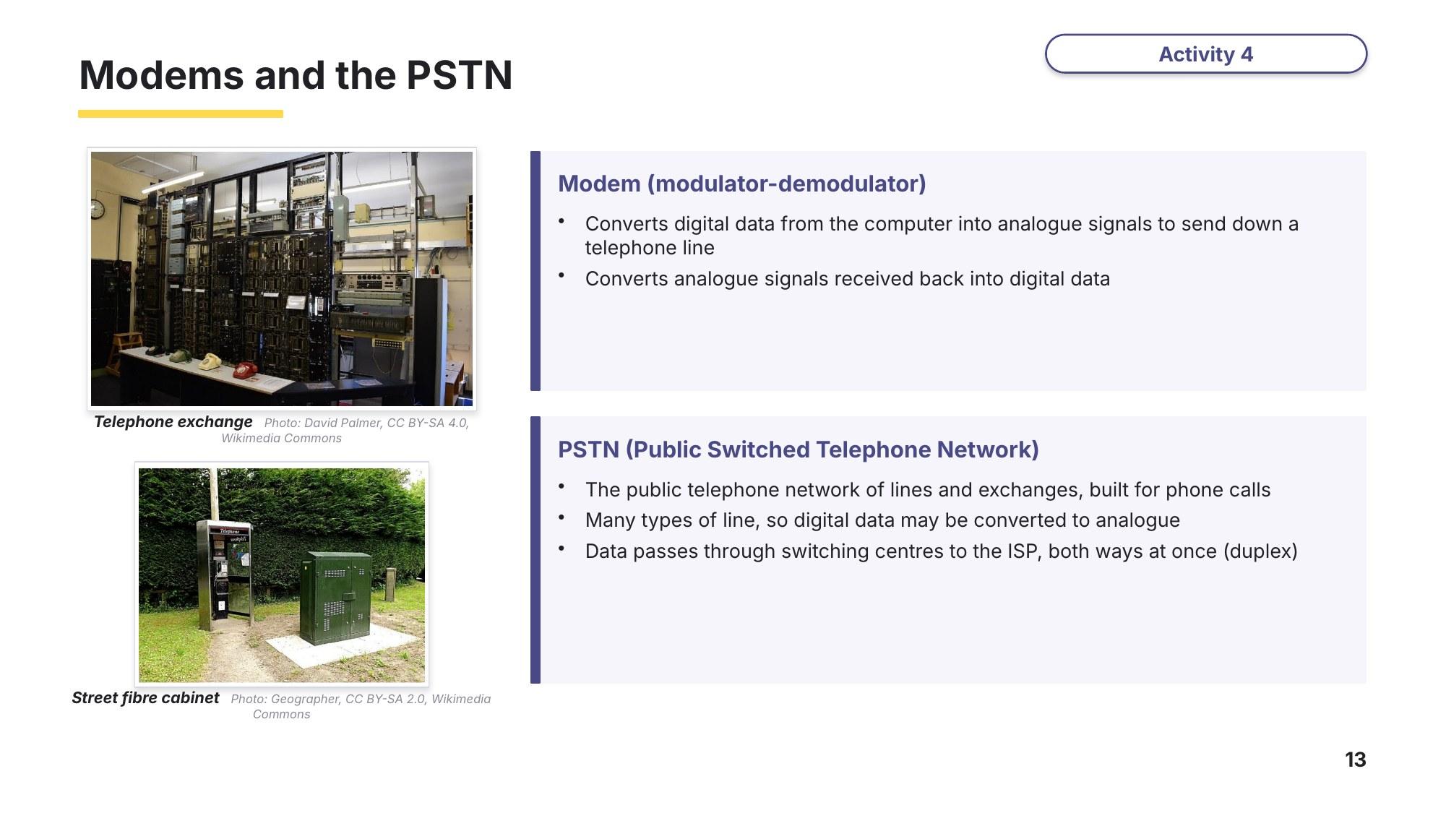
Slide 13 - Modems and the PSTN
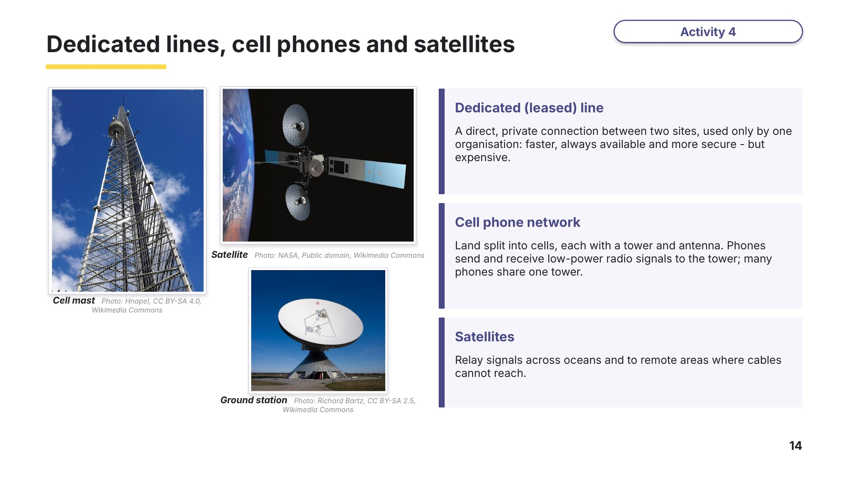
Slide 14 - Dedicated lines, cell phones and satellites

Task 3 The internet and its hardware [9 marks]
(a) Melinda sends emails from her webmail account (email account accessed through a website). Explain whether Melinda is using the internet, or the World Wide Web (WWW), or both. [3]
9618/11 May/June 2021 Q4(d).

(b) The video conference is accessed over the internet. Complete the table by stating how modems and dedicated lines are used when data is transmitted over the internet. [2]
9618/11 May/June 2025 Q2(c).
Hardware | How it is used
Modem
Dedicated line

(c) Describe the role of the PSTN (Public Switched Telephone Network) in the transmission of data through the internet. [2]
9618/12 May/June 2024 Q3(c)(ii).

(d) The smartphones use the cell phone network to connect to the WAN. Explain how data is transmitted using the cell phone network. [2]
9618/12 May/June 2025 Q6(b).

Learn IP addresses
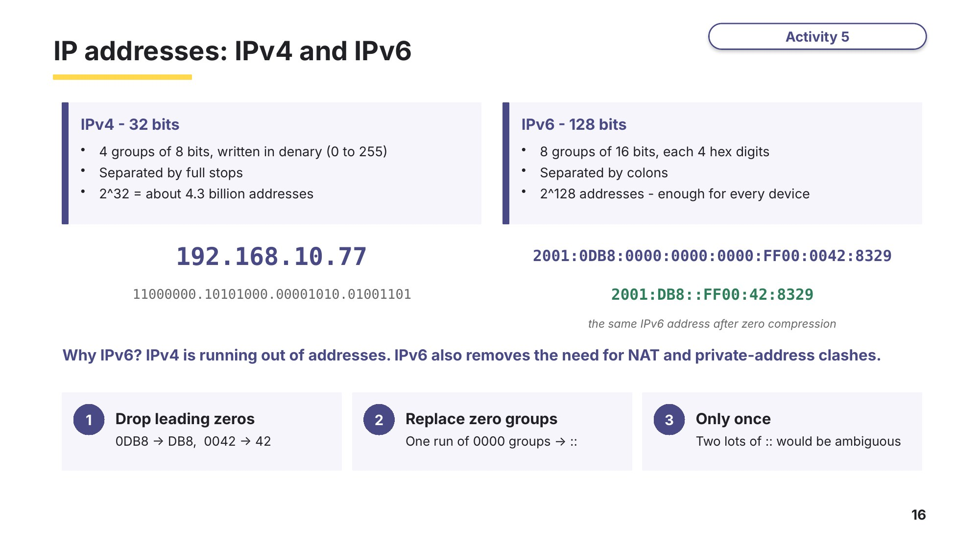
Slide 16 - IPv4 and IPv6
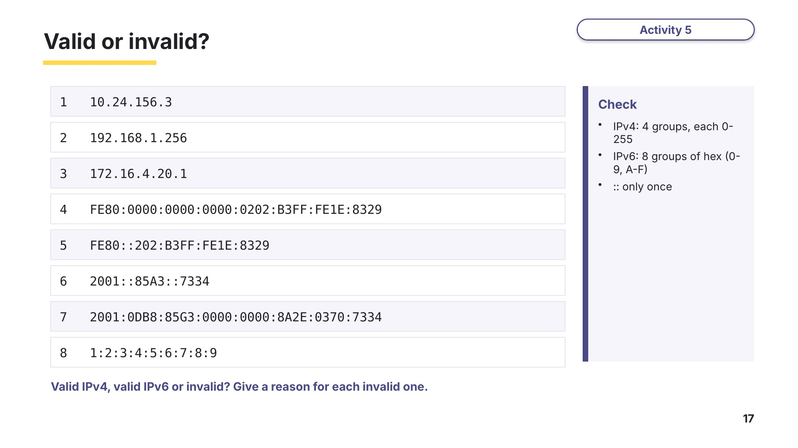
Slide 17 - Valid or invalid? (practice)
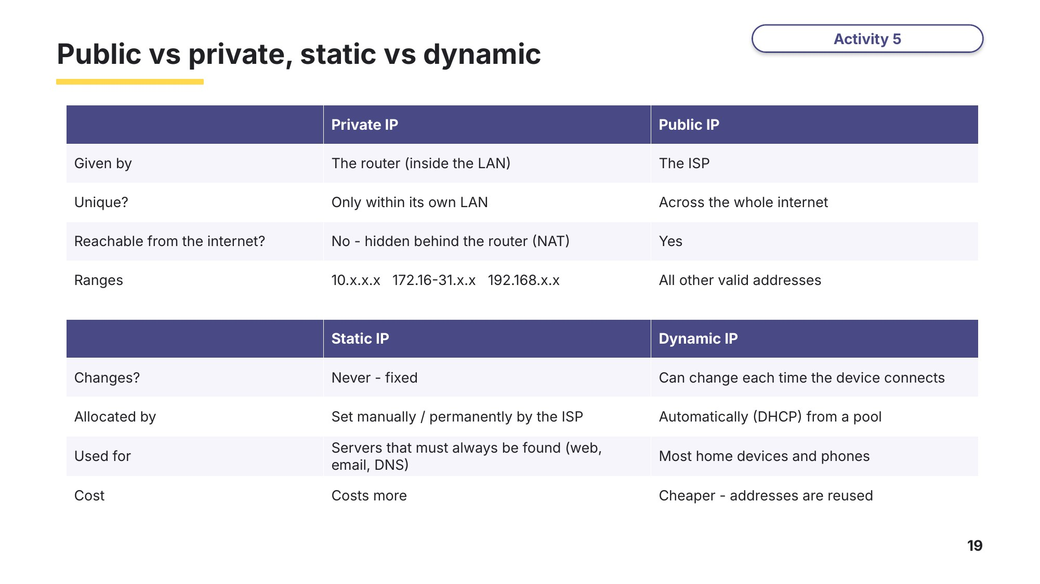
Slide 19 - Public vs private, static vs dynamic
Task 4 IP addresses [15 marks]
(a) Each device on the network has an IP address. Complete the description of IP addresses. [5]
9618/11 May/June 2023 Q4(d)(i).
An IPv4 address contains ................ groups of digits. Each group is represented in ................ bits and the groups are separated by full stops.
An IPv6 address contains ................ groups of digits. Each group is represented in ................ bits. Multiple groups that only contain zeros can be replaced with a ................ .
(b) The server has the IP address 192.168.3.2. Explain why this is not an IPv6 address. [2]
9618/12 October/November 2023 Q7(a).

(c) Tick one box in each row to show whether each address is a valid IPv4 address, a valid IPv6 address, or invalid. [4]
Exam-style question.
Address | Valid IPv4 | Valid IPv6 | Invalid
172.16.254.1
10.0.300.12
2001:DB8:0:0:8D3:0:0:2
FE80::1::A2

(d) Complete the table by writing the missing types of IP addresses and the missing descriptions. [4]
9618/12 October/November 2023 Q7(d).
Type of IP address | Description
 | Assigned to a device to allow direct access on the internet
 | Used for internal LAN communication only
Static
Dynamic
Learn Exam technique - check your Task 4 answers
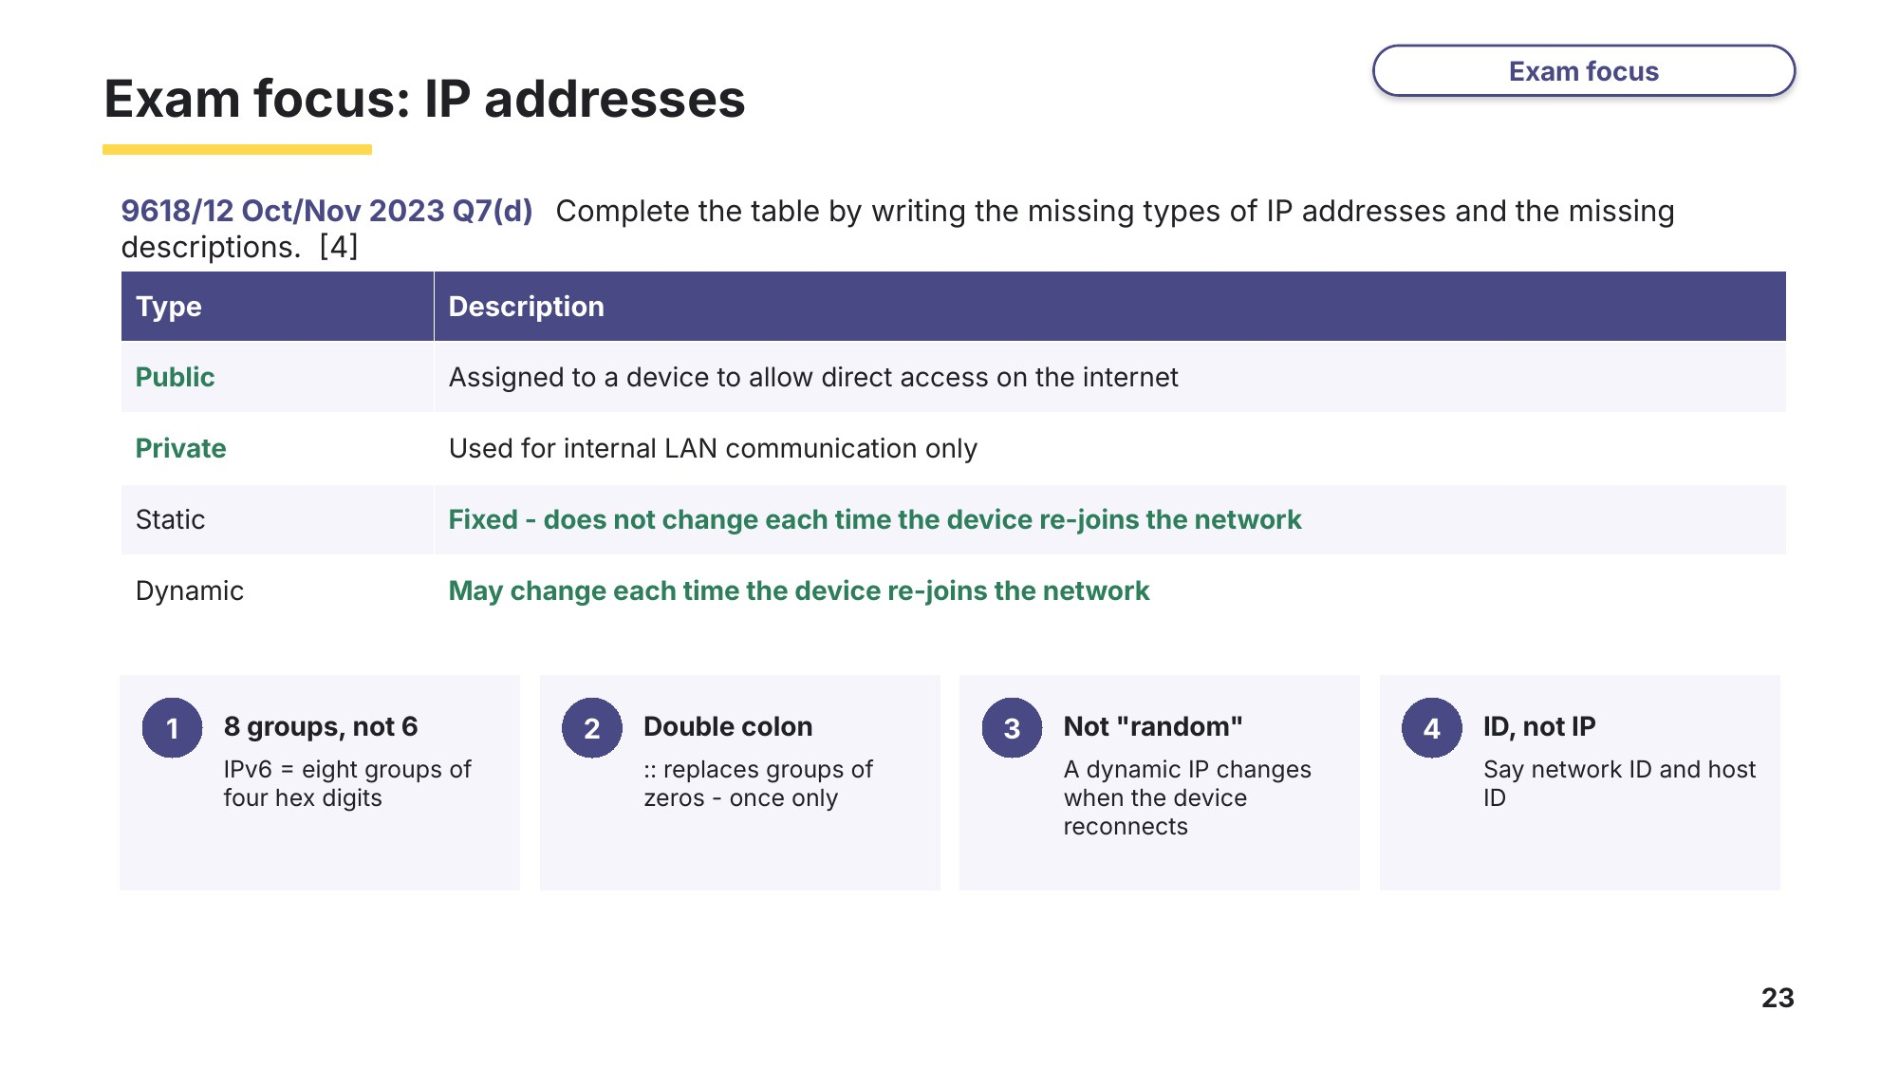
Slide 23 - Exam focus: IP addresses

Learn Subnetting, URLs and DNS
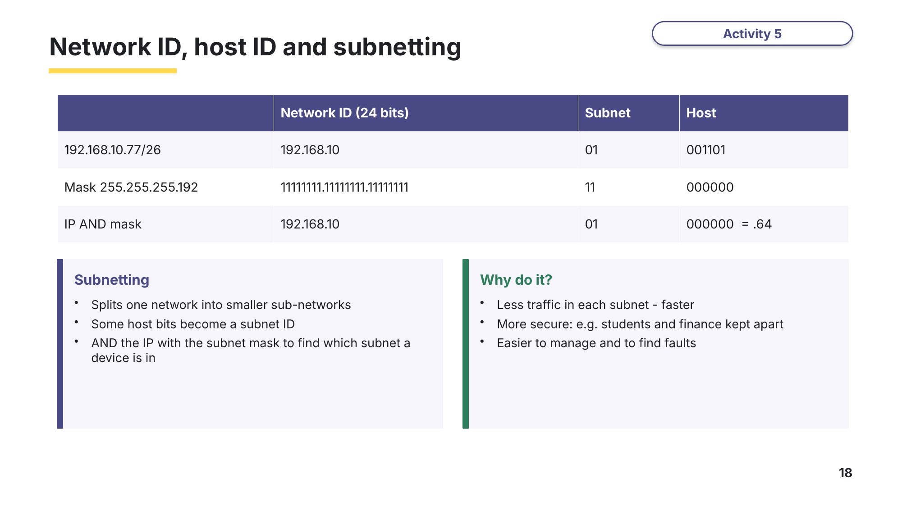
Slide 18 - Network ID, host ID and subnetting
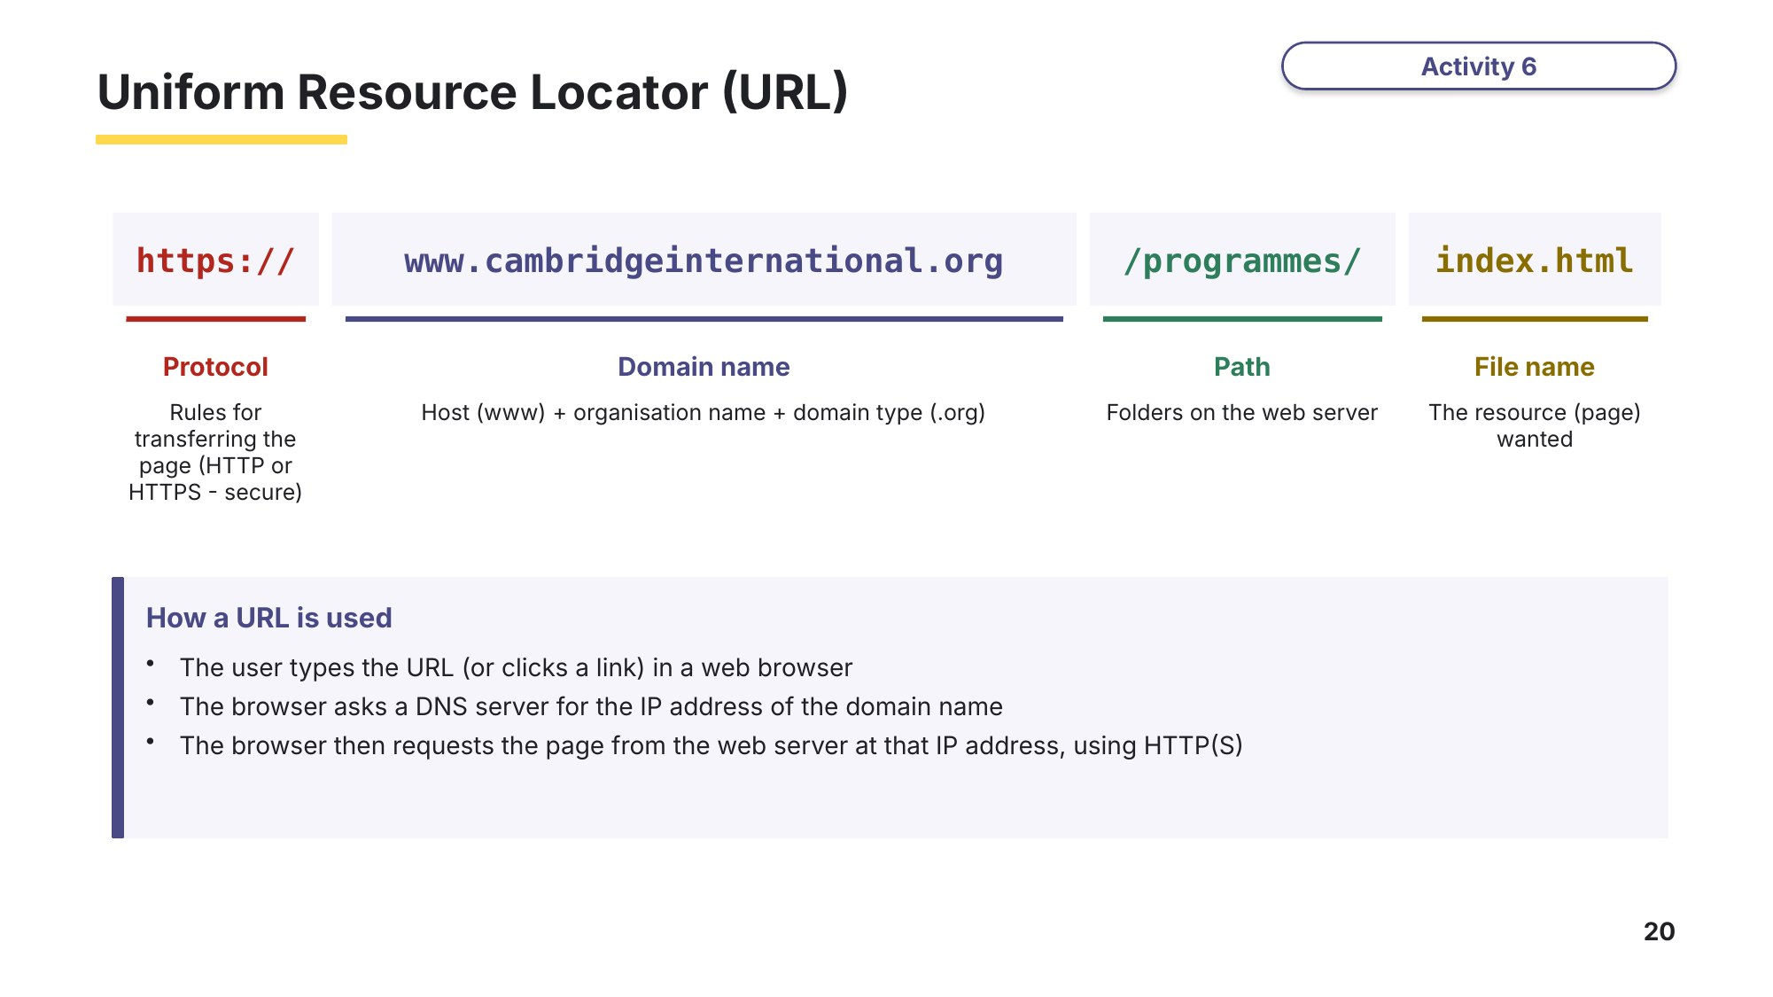
Slide 20 - Uniform Resource Locator (URL)
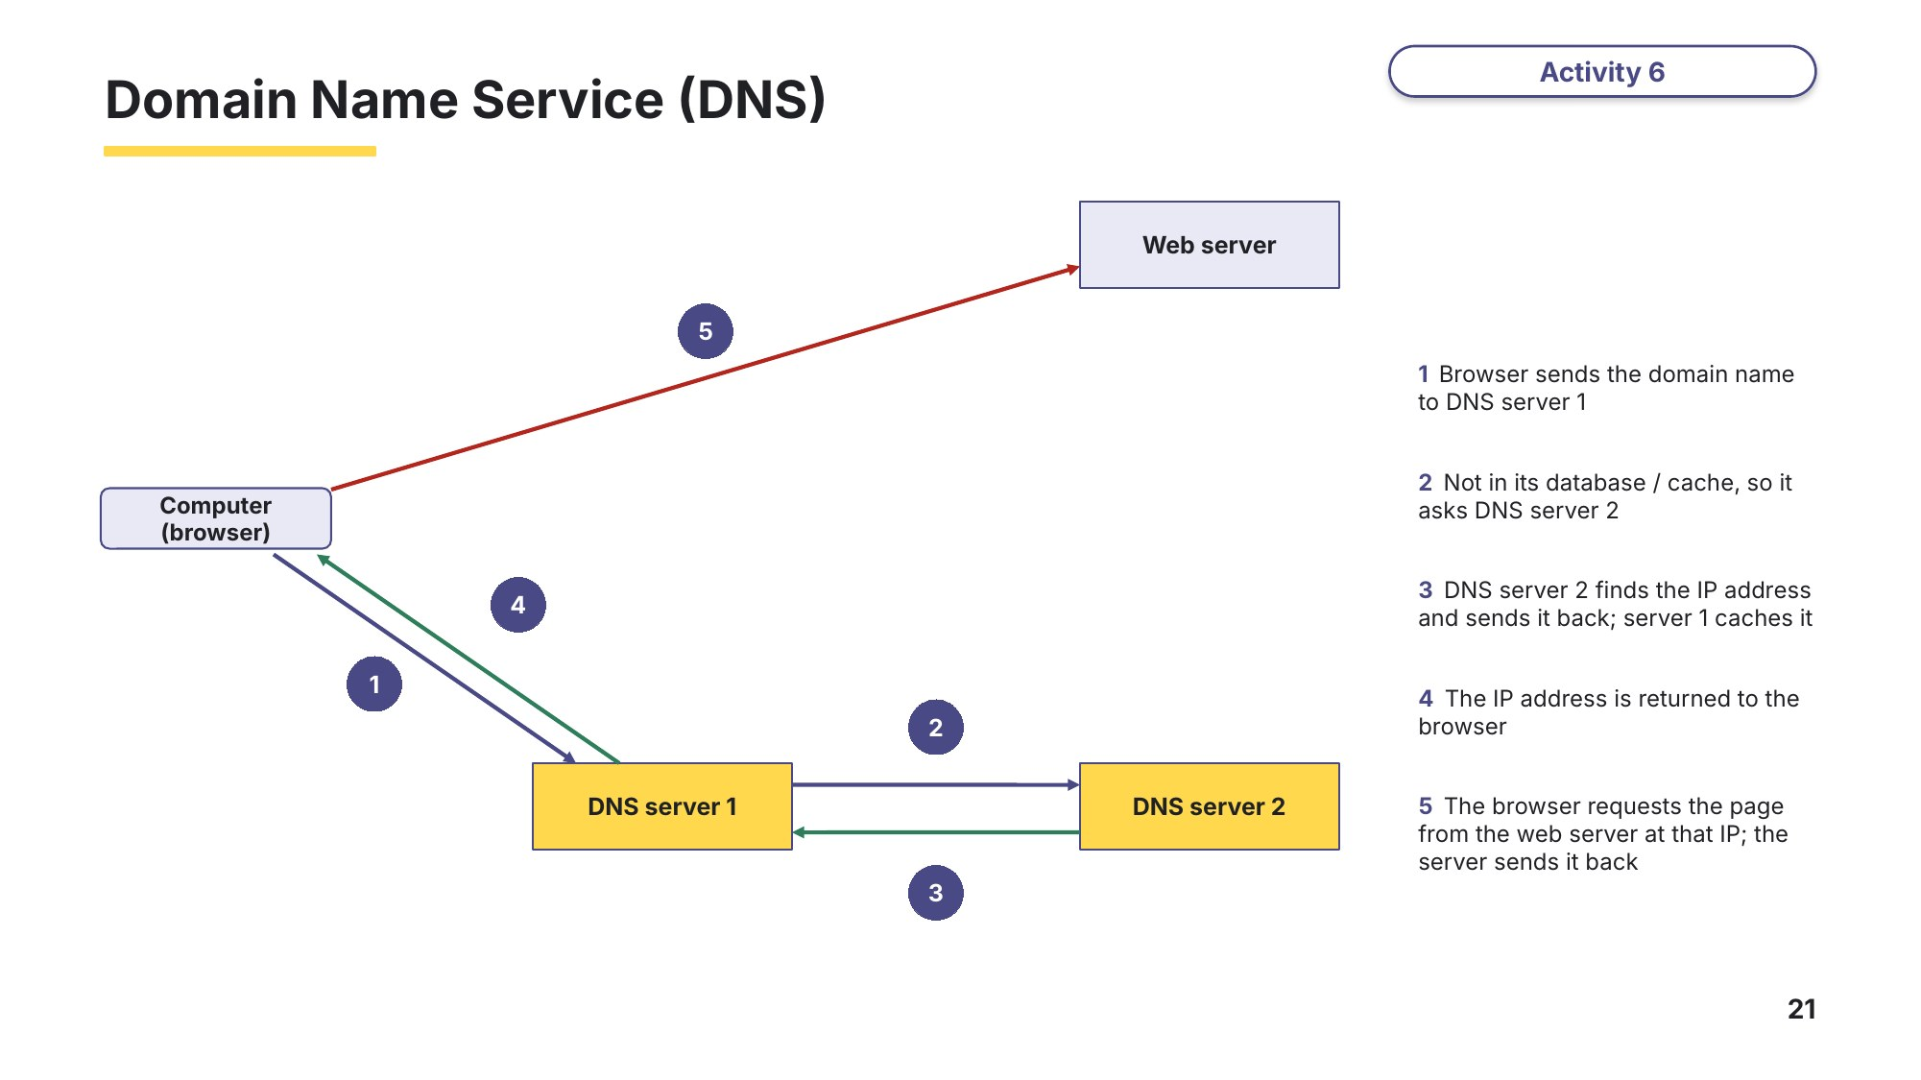
Slide 21 - Domain Name Service (DNS)
Task 5 Subnetting, URLs and DNS [13 marks]
(a) Two devices are on different subnetworks. Device 1 has the IP address 10.10.12.1 and the subnet mask 255.0.0.0. Device 2 has the IP address 192.168.12.4 and the subnet mask 255.255.255.0. [2]
Based on 9618/13 October/November 2022 Q7(c)(ii).
Identify the network ID of device 1 .........................................
Identify the host ID of device 2 .........................................
(b) Describe two benefits of subnetting a network. [4]
9618/11 May/June 2023 Q4(d)(ii).
1

2

(c) A student types this URL into a web browser:
https://www.cambridgeinternational.org/programmes-and-qualifications/
Identify the protocol, the domain name and the path in the URL. [3]
Exam-style question - there are no 9618 Paper 1 questions on URLs yet.
Part | From the URL
Protocol
Domain name
Path

(d) Explain how the Domain Name Service (DNS) is used to find the web page when the URL is entered. [4]
Exam-style question.

Task 6 Extension or homework [10 marks]
A company holds video conferences over the internet using real-time bit streaming.
(a) Explain the reasons why a video is compressed before it is transmitted using real-time bit streaming. [4]
9618/11 May/June 2025 Q2(b)(i).

(b) Identify whether the lossy or lossless compression method is more appropriate for the video conference. Justify your choice. [3]
Based on 9618/11 May/June 2025 Q2(b)(ii).

(c) A device has the IP address 172.16.5.200 and the subnet mask 255.255.255.224. Apply the subnet mask (AND) to find the address of the subnet the device is in. Show your working in binary for the last group. [3]
Exam-style question (use of subnetting).

Learn Review
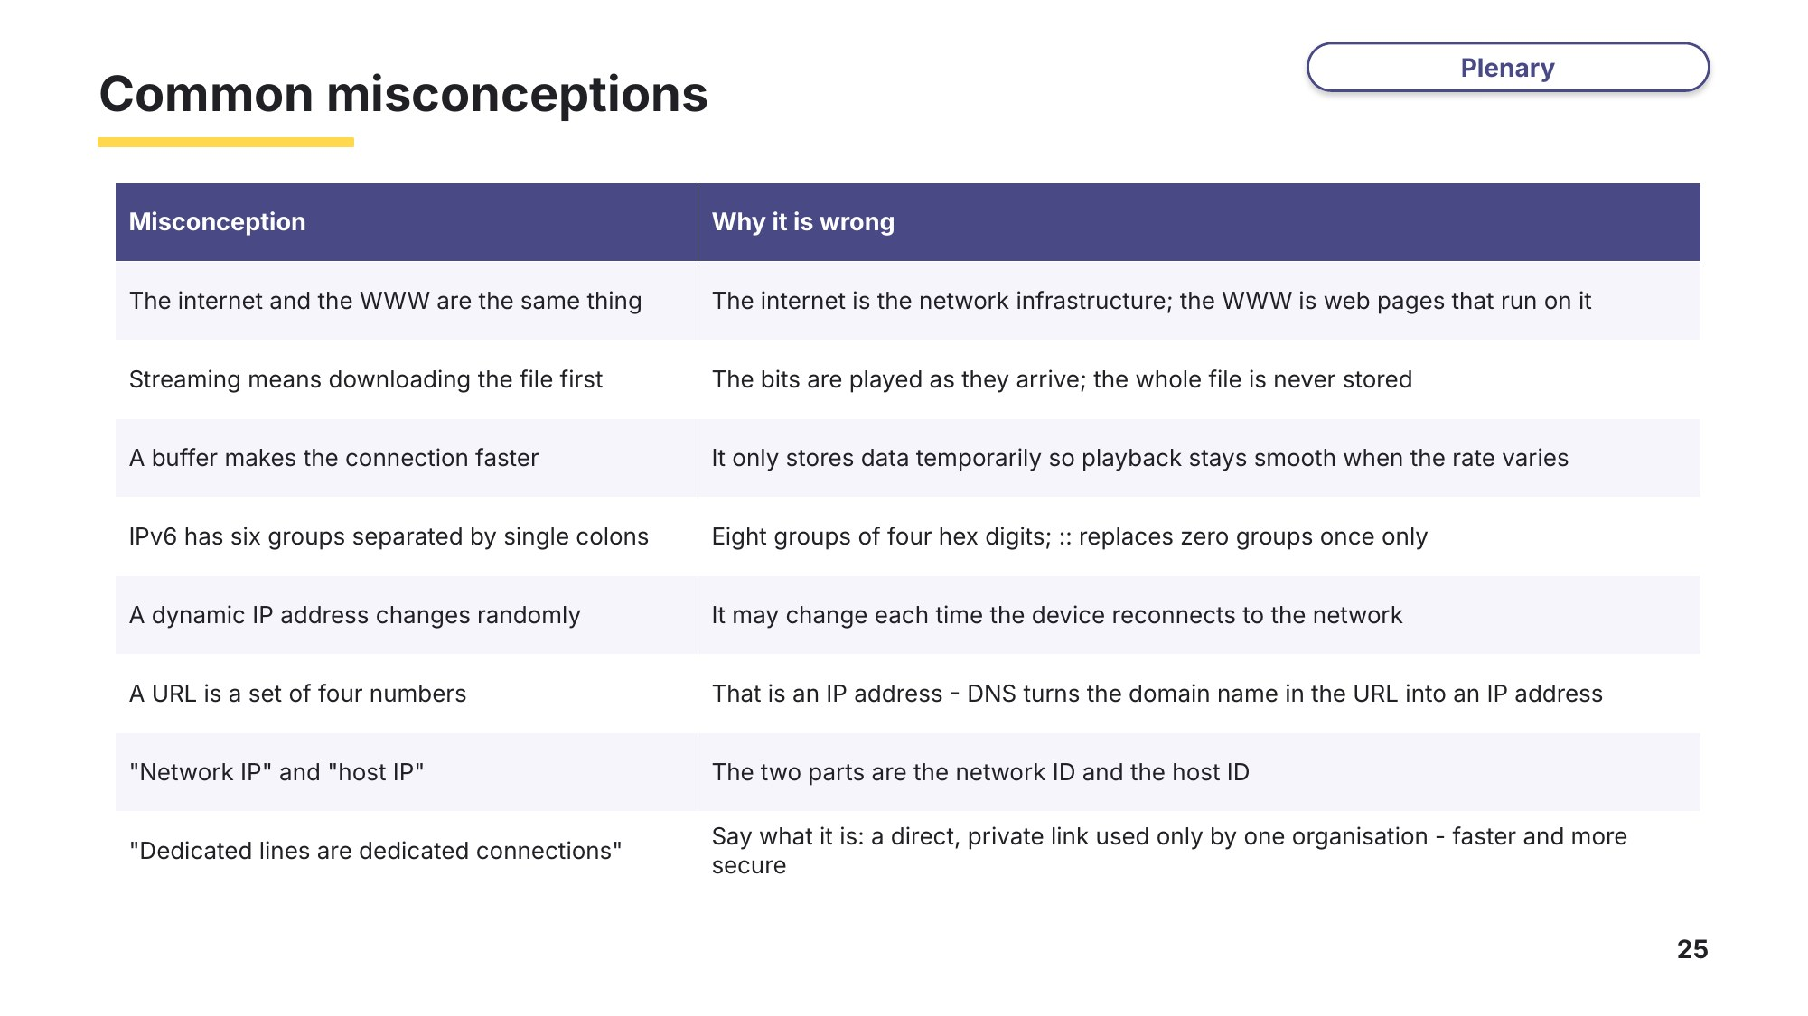
Slide 25 - Common misconceptions
Look back at your Task 1 answers and at the misconceptions above. Which did you believe before this lesson?
Exit question
(a) State one difference between real-time and on-demand bit streaming. [2]

(b) A user types www.bbc.co.uk into a browser. Explain the role of the DNS. [2]

(c) Write down a valid IPv6 address that uses zero compression. [1]

